

Faculty of Engineering and Applied Sciences

SOFE4640: Mobile Application Development

# **Fit My Life**

Final Project Report

**Team Members:**

Nathan Bojczuk: 100749012

Gobikah Balaruban: 100742539

Karanvir Bhogal: 100748973

Manreet Kaur: 100766207

**GitHub Project Link:** <https://github.com/NathanBoj/FML>

**Problem Statement**

Almost everyone wants to live a healthy life and exercise regularly, but when it comes to actually implementing these habits, it is a lot more difficult than it seems. Fit_My_Life app is a fitness tracking app which will help the people to track their food intake and exercise so that they can keep healthy. To top it all off, users will be able to login with their own personal accounts so all of their fitness data stays safe and organized.

**Goals, Requirements, and Analysis**

Our goals for this application were to provide multiple features for maintaining a healthy lifestyle, without compromising on the quality of any of them. These features include recording meals, recording calories lost/gained, recording water consumption, finding healthy recipes, calculating BMI/weight, finding workout routines, and setting personal goals. For the final product, we were successfully able to implement all of these features without many issues.

Alongside our personal goals, we also had to meet the requirements provided to us for this project. These requirements included having multiple activities with intents, implementing a save state mechanism, utilizing a centralized database, and implementing the use of API’s. We were able to fulfill these requirements in our final product without much issue.

Overall, implementing all of the features ended up being slightly easier than we were expecting. The thing which we ended up having the most difficulty with was combining everyone’s work into one project. We would encounter issues with the Gradle builds, Android SDK versions, or just the emulator itself. However, through perseverance, we were finally able to successfully pull together our final application and get everyone’s parts working.

**The App Architecture**

***App Architecture Diagram of Fit My Life Mobile Application***

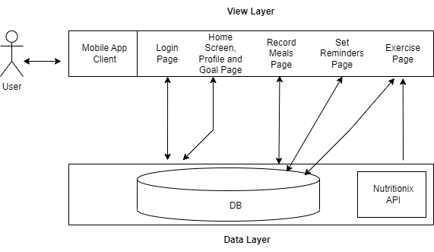

**Tools Utilized**

The tools used to complete the Fit My Life project include, Android Studio, Java, Firebase Authentication, and Firebase Realtime Database. The application was written in Java using Android Studio, which helped with organizing the user interface layouts and emulating the app to test for bugs. Our group also utilized Google's hosting services Firebase, which allowed us to create a global database for our users and store their information. Firebase Authentication helped verify users login credentials when signing into our application.

**User Interfaces**

**Login/Register:**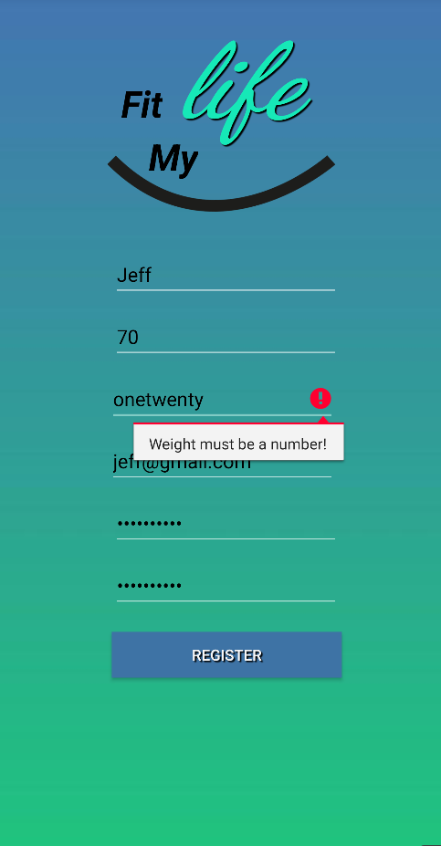

Users may login with a valid email and password.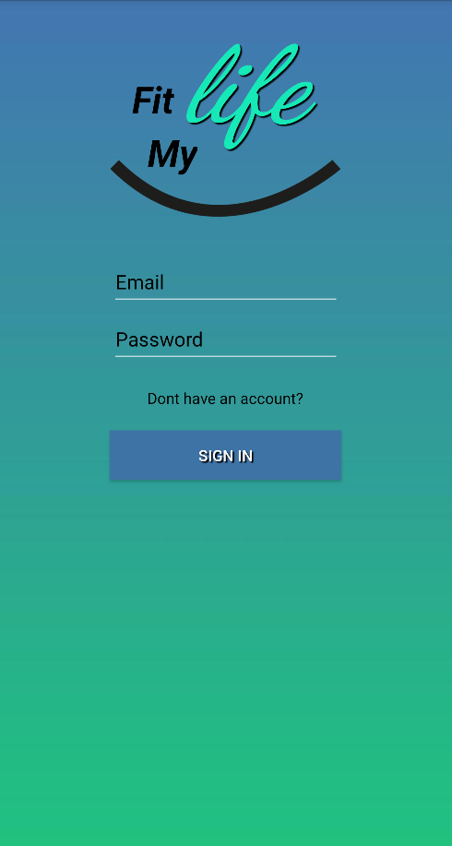

They may sign up by providing name, height, current weight, email, and password.

Input validation is used to prevent user error and hacker injections.

Centralized database is used to register and login a user.

**Home Screen:**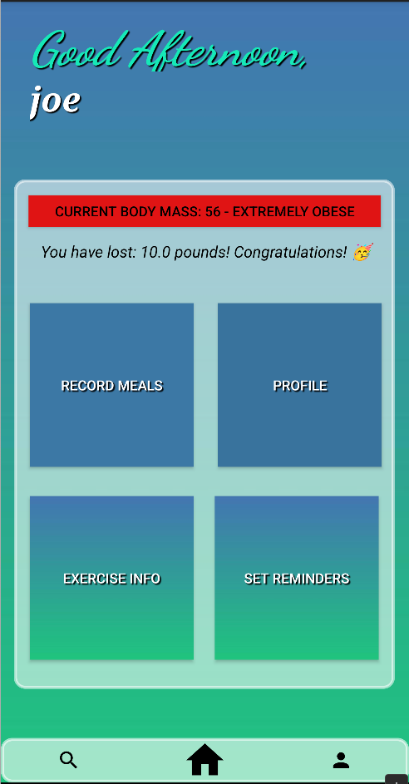

Home screen is easy to use and displays key information.

Current body mass index and how much weight you have lost is shown, and changes depending if you gain or lose weight. This is meant to help motivate the user through our app.

Can easily access all functionality from this primary page.

**Profile Page:**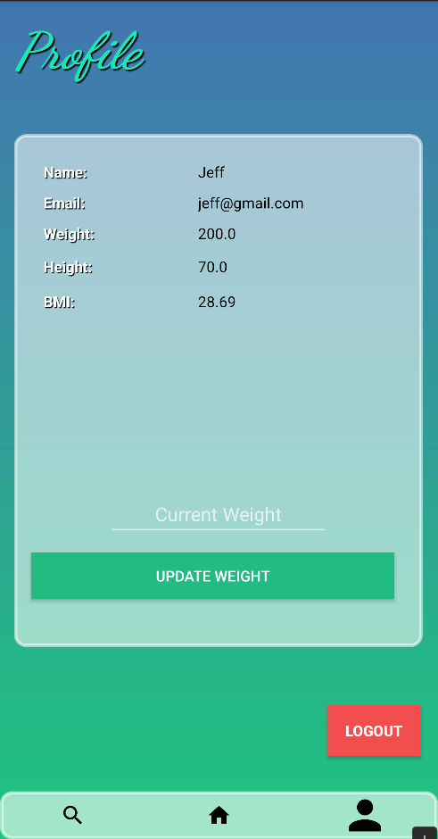

Users can easily view all of their key information. They can also update their weight and log out from this page.

**Goals Page:**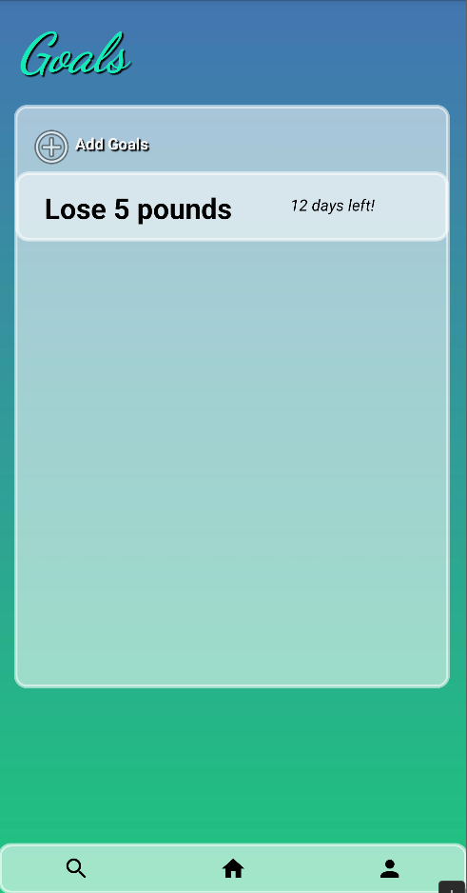

The goals page helps motivate users as they can set goals and the date by when to achieve it.

Users can swipe to remove goals they have achieved or mistakenly added.

App reminds the user 3 days before the goal expires.

Save state mechanism is used together with Firebase to keep track of user sensitive goals.

**Exercise Info Page:**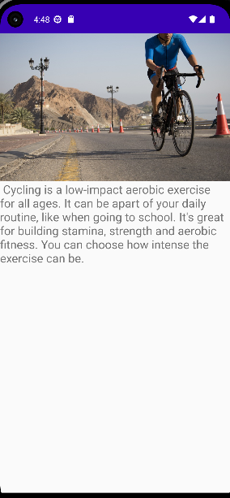

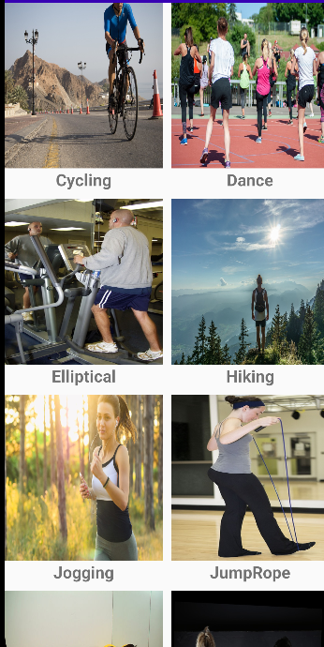

Users can browse through exercises in the Exercise Info page. A gridview is provided, allowing users to see multiple exercises on the page. If they click on one of the exercises, they are brought to a new page describing the exercise, what the exercise is good for, and the intensity of the exercise. Intents were used when a user clicks on the exercise.

**Record Meals Page:**

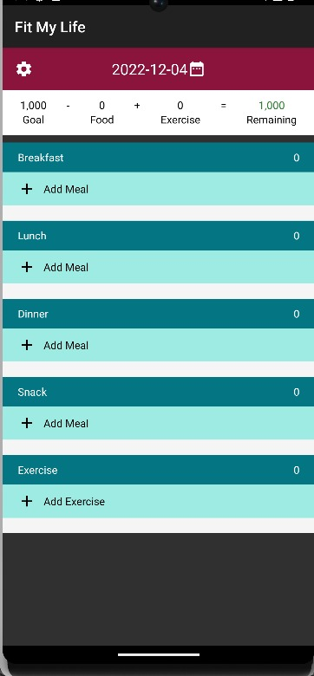

Users can record their meal plans in the Record Meals Page. They can record breakfast, lunch, dinner, and snack meals to their schedule. They can add these meals by pressing “Add Meals” and can search for the food(s) they would like to add, with the use of the Nutritionix API.

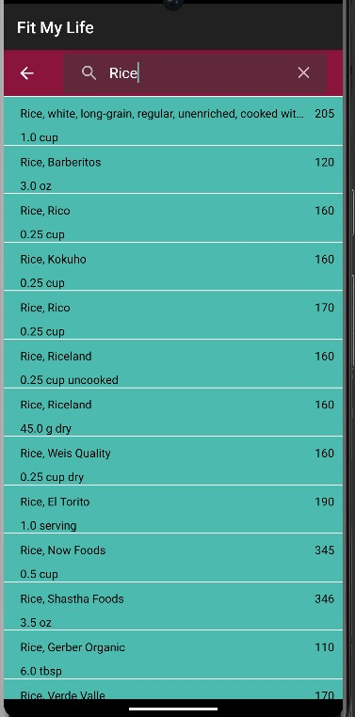

For instance, if they want to add “Rice” for breakfast, they can search for rice and the autocomplete feature will show a list of items related to that search, providing the name of the food, serving size and the amount of calories.

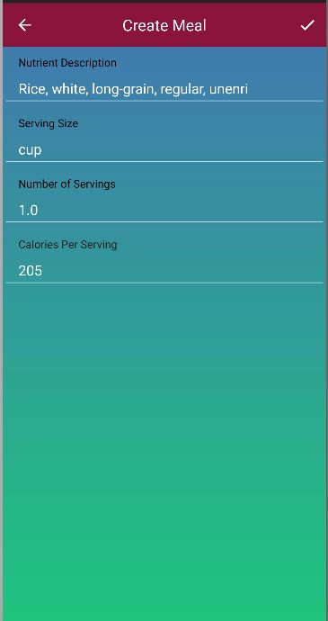

Once clicking on the type of food, they are provided with more details and have the option to go back to keep searching or press the check and finish creating the meal plan.

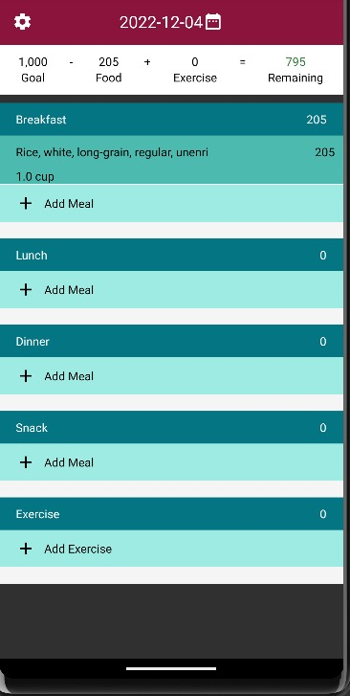

Now, the meal is added to the plan. The calories are accounted for at the top of the page with the remaining calories showing. There is also a portion to manually add an exercise.

**References**

<https://www.nutritionix.com/business/api>